Diabetes Risk Detection

**Gender has the highest prevalence of diabetes**

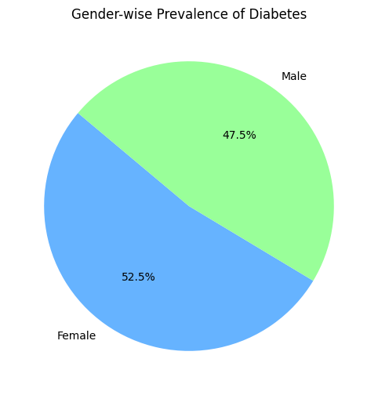

Gender with highest prevalence of diabetes: Female

# Gender has a higher chance of developing diabetes, and how does this vary with age

# 

# The figure above shows that if any gender crosses the age of 40, especially males and females, the risk of diabetes increases. However, it also depends on other factors as well.

# hypertension increase the risk of developing diabetes

# 

Number of people with hypertension who developed diabetes: 7479

Number of people without hypertension who developed diabetes: 92455

# here is no strong relationship between hypertension and diabetes. The above figure shows that having no hypertension does not necessarily mean that one does not have diabetes. The data indicates that diabetes does not depend on the presence of hypertension. Now let's determine whether there is a relationship between heart diseases and diabetes.

# heart attack increases a person's risk of developing diabetes?

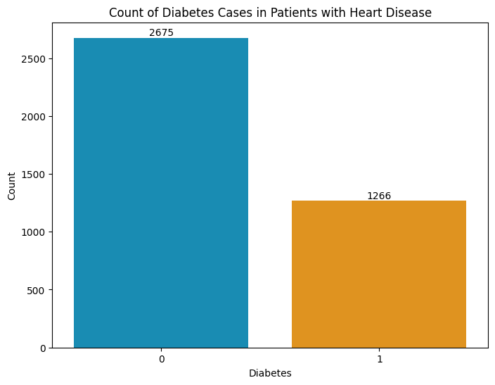

The figure shows a total of 3941 heart patients, of which 1266 have diabetes and 2675 do not have diabetes.

Similar to hypertension, there is no strong relationship between heart disease and diabetes. Diabetes can occur regardless of whether a person has heart disease or not, as it depends on other factors.

# hypertension and a heart attack impact the risk of developing diabetes

# 

# The pie chart shows that if a person has both hypertension and heart disease, they have a 39% chance of also having diabetes. If they do not have diabetes, they have a 61% chance.

**Let's analyze the diabetes gender wise in people with both hypertension and heart disease**

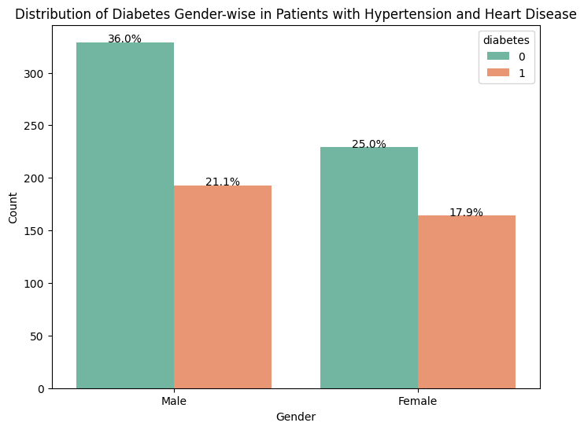

The above figure shows that 21% of males and 17.9% of females who have both hypertension and heart disease also have diabetes.

# link between smoking and diabetes

# 

# * People who never smoke have diabetes counts of 3344, and 31723 people who never smoke do not have diabetes.

# * People with diabetes count 1453, and 34337 people without diabetes do not have information about whether or not they have diabetes.

# * People who currently smoke have diabetes counts of 947, and 8337 people who currently smoke do not have diabetes.

# * People who have ever smoked have diabetes counts of 471, and 3530 people who have ever smoked do not have diabetes.

# * People who never smoke have diabetes counts of 689, and 5754 people who never smoke do not have diabetes.

**Hemoglobin Impact at Diabetes**

Minimum HbA1c Level: 3.5

Maximum HbA1c Level: 9.0

Mean HbA1c Level: 5.527447115095963

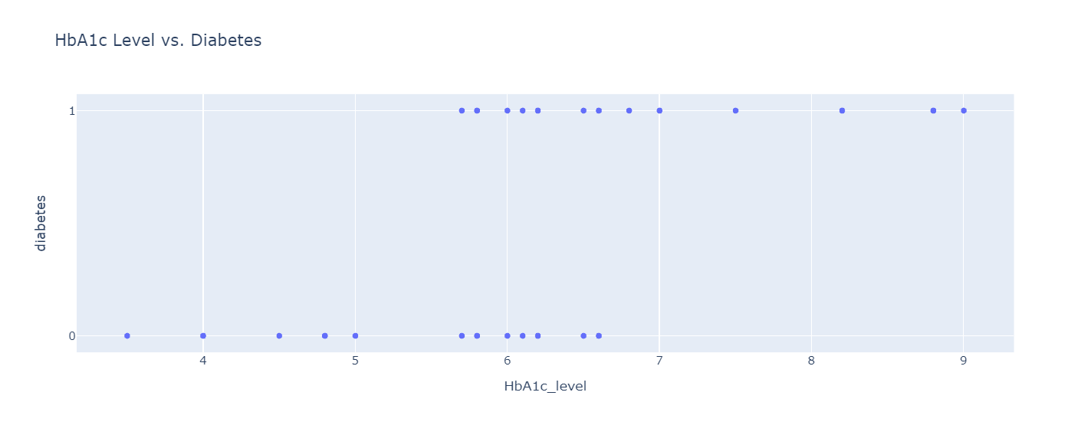

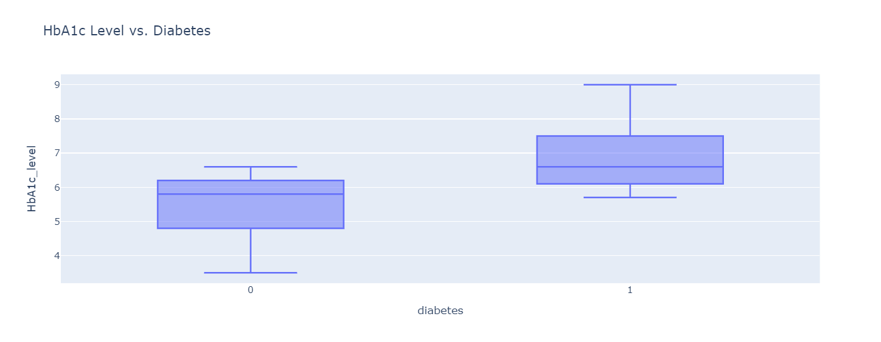

There is a significant relationship between hemoglobin and diabetes. The above figure indicates that a hemoglobin level ranging from 4.8 to 6.2 is considered healthy. However, if a person has an HbA1c level higher than 6.1, it could be considered risky. There are many people with a hemoglobin level lower than 6.8 who have diabetes, potentially due to their high glucose levels. However, diabetes risk also depends on other factors. There is a high chance of diabetes risk. To verify this relationship, let's create a box plot. Additionally, let's create another dataframe that specifically includes individuals with an HbA1c level greater than or equal to 6.8, enabling us to analyze the associated diabetes risk.

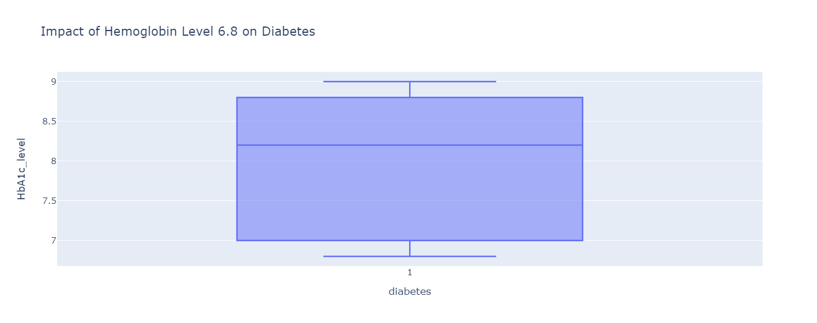

The above figure indicates that if the hemoglobin level is greater than 6.8, there is a high likelihood of diabetes risk based on the data. now let's check the the relation between blood glucose level with diabetes.

**Relation Between Diabetes and Blood Glucose**

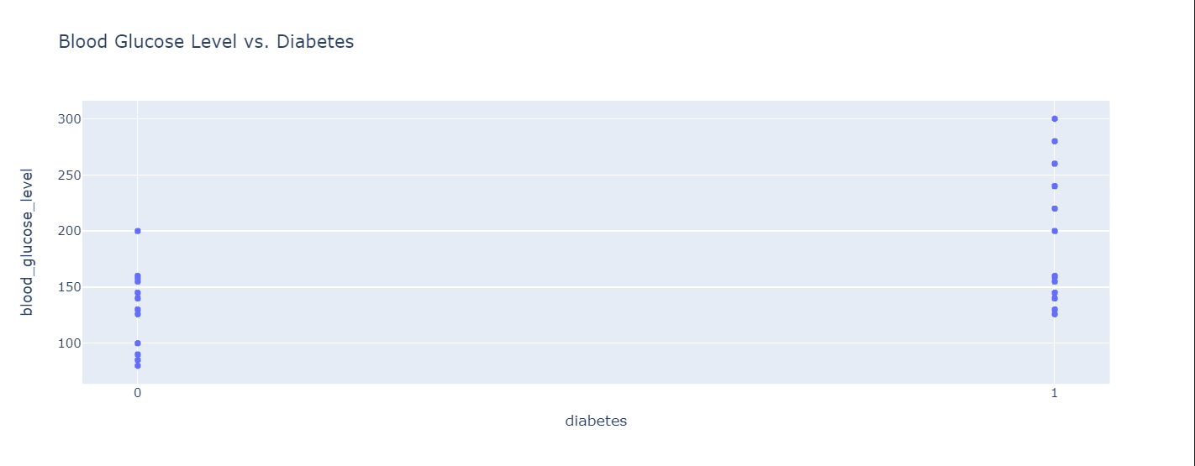

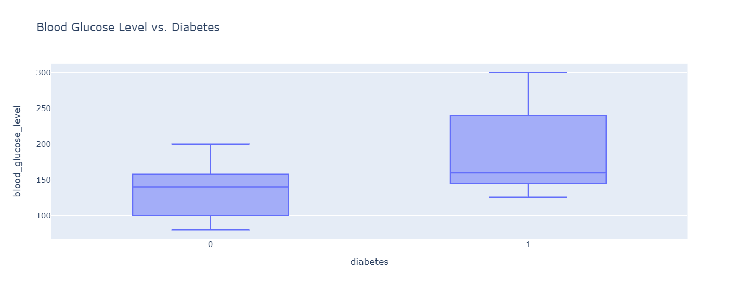

minimum level of blood Glucose 80

maximum level of blood Glucose 300

Average level of blood Glucose 138.0551864230392

We can observe a significant relationship between blood glucose levels and diabetes. The figure shows that the range between 100 and 160 in blood glucose levels is mostly considered healthy. However, the range between 160 and above is considered risky, and when the glucose level exceeds 200, the chances of diabetes risk are very high. Now, let's create another dataframe that consists of values where the glucose level is greater than or equal to 200 and identify the number of individuals with diabetes.

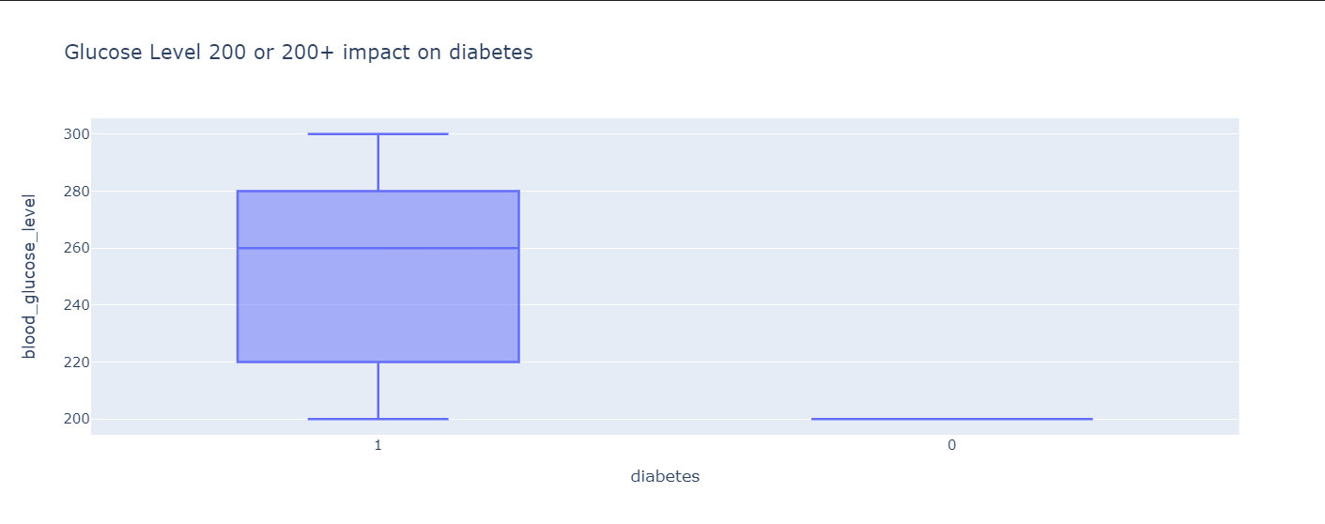

The above figure indicates that, based on the data, there are many people with a blood glucose level of 200 who do not have diabetes, likely due to their hemoglobin level being less than 6.8. Diabetes risk depends on other factors as well. Diabetic patients are most commonly found within the blood glucose level range of 220 to 280.

**Relation between BMI and Diabetes**

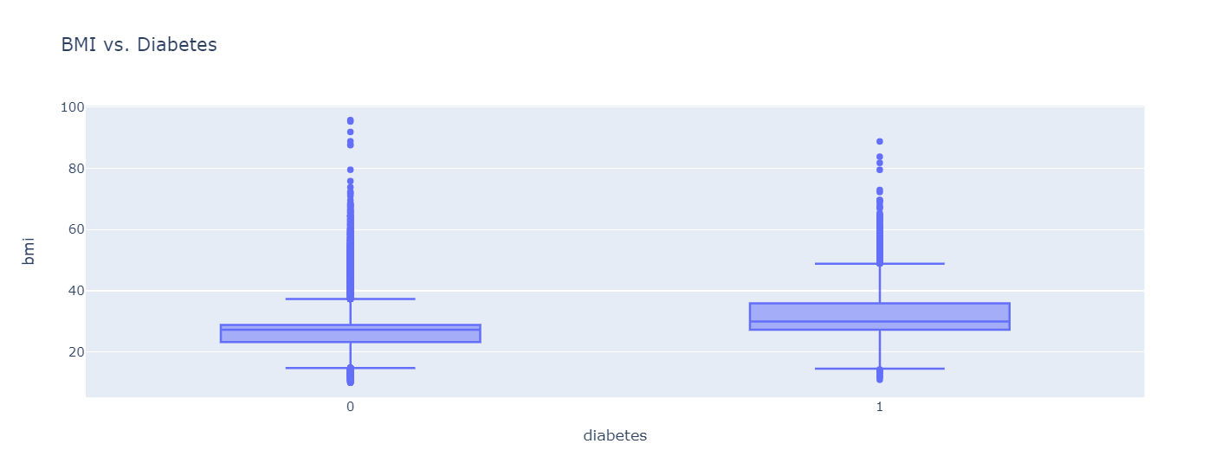

We can observe that there is no strong relationship between BMI and diabetes. If a person has a low BMI score, the risk of diabetes increases; similarly, when a person has a high BMI, the chances of diabetes risk also increase, potentially affecting both conditions.

**Model Selection**

We used three models, namely the decision tree classifier, random forest classifier, and logistic regression classifier, for a classification problem.

**RandomForestClassifier:**

Model Score: 0.9689298043728424

**LogisticRegression:**

Model Score: 0.9575724220743483

DecisionTreeClassifier:

Model Score: 0.9532195927352779

We can see that the Random Forest Classifier performs better than the other models, with a better score than the Logistic Regression Classifier and the Decision Tree Classifier.

**I created a web app that can predict whether a person has diabetes or not using a random forest classifier model.**

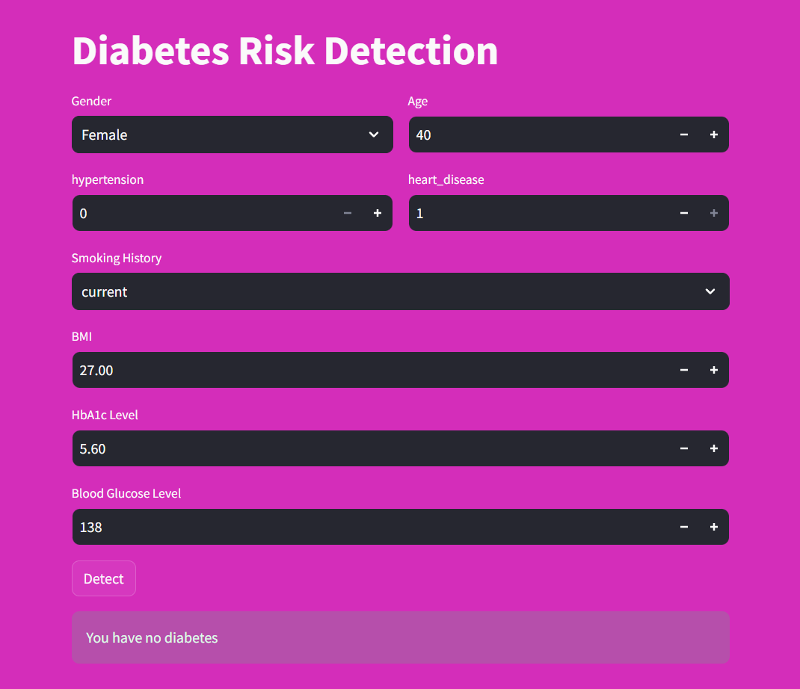

**Conclusion:**

the following key risk factors for diabetes can be identified:

Age: The risk of diabetes increases with age, especially after 40 years old.

Hemoglobin level: A hemoglobin level above 6.8 is a significant risk factor for diabetes.

Blood glucose level: A blood glucose level above 200 is also a significant risk factor for diabetes.

There is no strong relationship between diabetes and hypertension, heart disease, or BMI. However, people with diabetes are more likely to have these other conditions.

**Recommendations:**

To reduce your risk of diabetes, it is important to maintain a healthy weight, eat a healthy diet, and get regular exercise. You should also have your blood sugar and hemoglobin levels checked regularly. If you have any risk factors for diabetes, such as being overweight, having a family history of diabetes, or being over 40 years old, you should talk to your doctor about how to manage your risk.